**1. OS install (CentOS 6.x 64bit)**

**Mr. Bien setup all!**

ssh kiet@103.39.94.24 -oHostKeyAlgorithms=+ssh-dss

**hanbiro!@#$123**

su -

**hanbiro!@#$123**

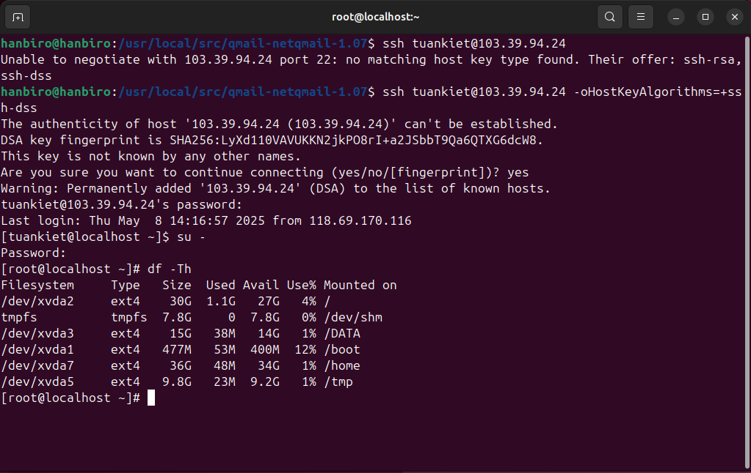

**2. ASP partition setting**

# vi /etc/fstab

UUID=e099bb12-619b-40ca-82b1-11acfd0f7bb3 / ext4 defaults,discard 1 1

UUID=a592d9e7-fb30-4625-8da2-69f1e397e127 /DATA ext4 defaults,discard,noatime,nodiratime,noquota 0 0

UUID=171c5b10-59bb-4443-82b1-288f197c41aa /boot ext4 defaults 1 2

UUID=b89b8be8-17cc-4fab-90e4-baa29de6e3b9 /home ext4 defaults,noatime,nodiratime,noquota 0 0

UUID=162549dd-8af7-41c3-83ad-07a457fc9b1f /tmp ext4 defaults,noexec,nosuid,discard,noatime,nodiratime 1 2

UUID=9bce35a7-5d09-448b-ad4f-5ec1139735c7 swap swap defaults 0 0

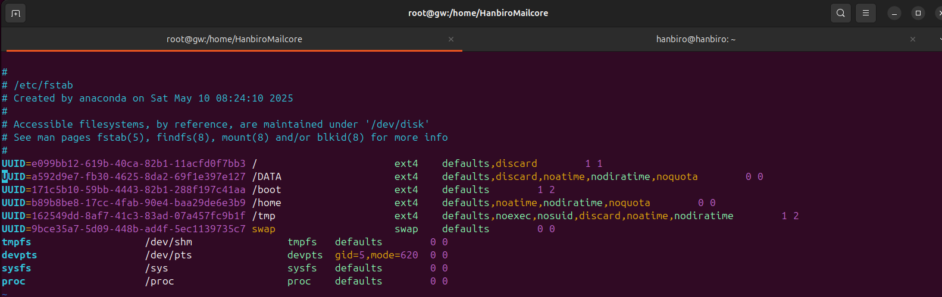

**3. Groupware Image install**

# yum -y install wget

# mkdir -p /home/IMAGE

# cd /home/IMAGE

# wget --user=hanbiro --ask-password<http://222.231.27.132/hanbiro_mrtg/IMAGE/INSTALL.tar.gz>

# tar xvzf INSTALL.tar.gz;rm -fv ./INSTALL.tar.gz

vi ./GWBIGINSTALL.sh

#############################################################

VPOPPASS="hanbiro!@#$123"

ROOTPASS="hanbiro!@#$123"

GWDOMAIN="kiethanbirooo.shop"

GWHOST="gw.kiethanbirooo.shop"

GWUSERCOUNT="10"

IPADDR="103.39.94.24"

EMAIL="test@kiethanbirooo.shop"

TEAMID="linux@kiethanbirooo.shop"

MANAGEID="kiet"

COUNTRY="VN" # KR, VN, CN, JP, US, IN

CASSANDRA_HEAP="2G"

ELASTIC_HEAP="6G"

Cassandra_DATA_Partition="home"

Elastic_DATA_Partition="DATA"

Mysql_DATA_Partition="DATA"

Mysql_LOG_Partition="DATA"

#############################################################

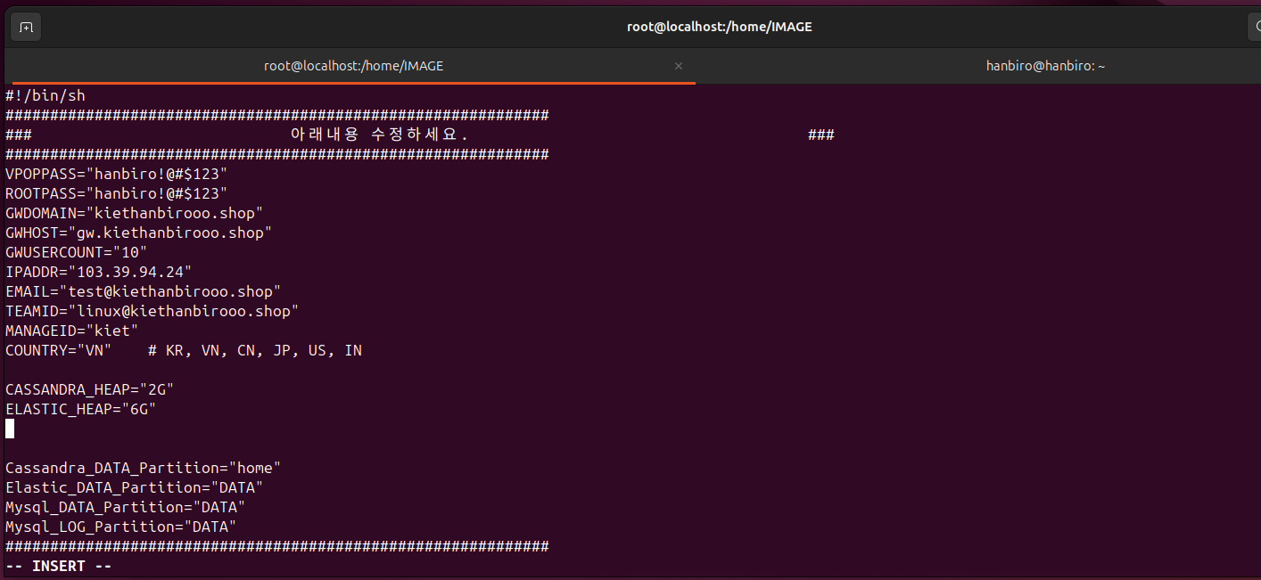

# sh GWBIGINSTALL.sh

*Postmaster Password :* ***ePuBeMu*uT***

# passwd kiet

**hanbiro!@#$123**

# passwd root

**hanbiro!@#$123**

# reboot

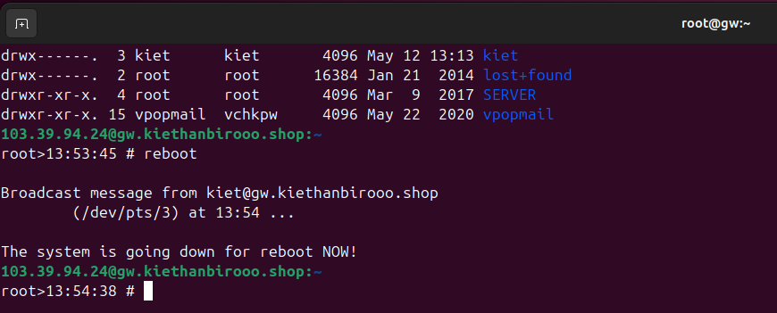

**4. ASP file add**

# cd /root/Hanbiro/GWS

# touch ASP

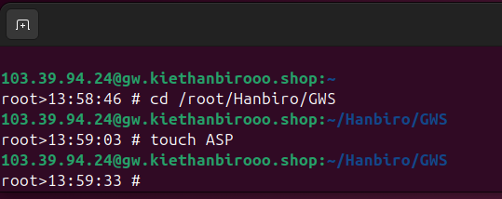

5. Adaptec SmartRAID Event Monitor install

Following the process belowed

#skip this step

<https://n.hanbiro.com/ngw/app/#/helpdesk/knowledgebase/view/628>

Groupware

N.HANBIRO.COM

**LINK ERROR**

6. moffice install

# cd /root/Hanbiro;wget --user=hanbiro --ask-password<http://git.winsblack.com/GWS/hanbiroM.tar.gz>;tar xvzf hanbiroM.tar.gz;rm -f hanbiroM.tar.gz

# vi /etc/init/moffice.conf (make file - To bring from another ASP)

# vi /root/Hanbiro/hanbiroM/bin/chat_port_add.php

Line 8 : $ip = "xxx.xxx.xxx.xxx";

# vi /root/Hanbiro/hanbiroM/bin/chat_port_del.php

Line 8 : $ip = "xxx.xxx.xxx.xxx";

# moffice operate

stop moffice / start moffice

**SKIP BECAUSE:**

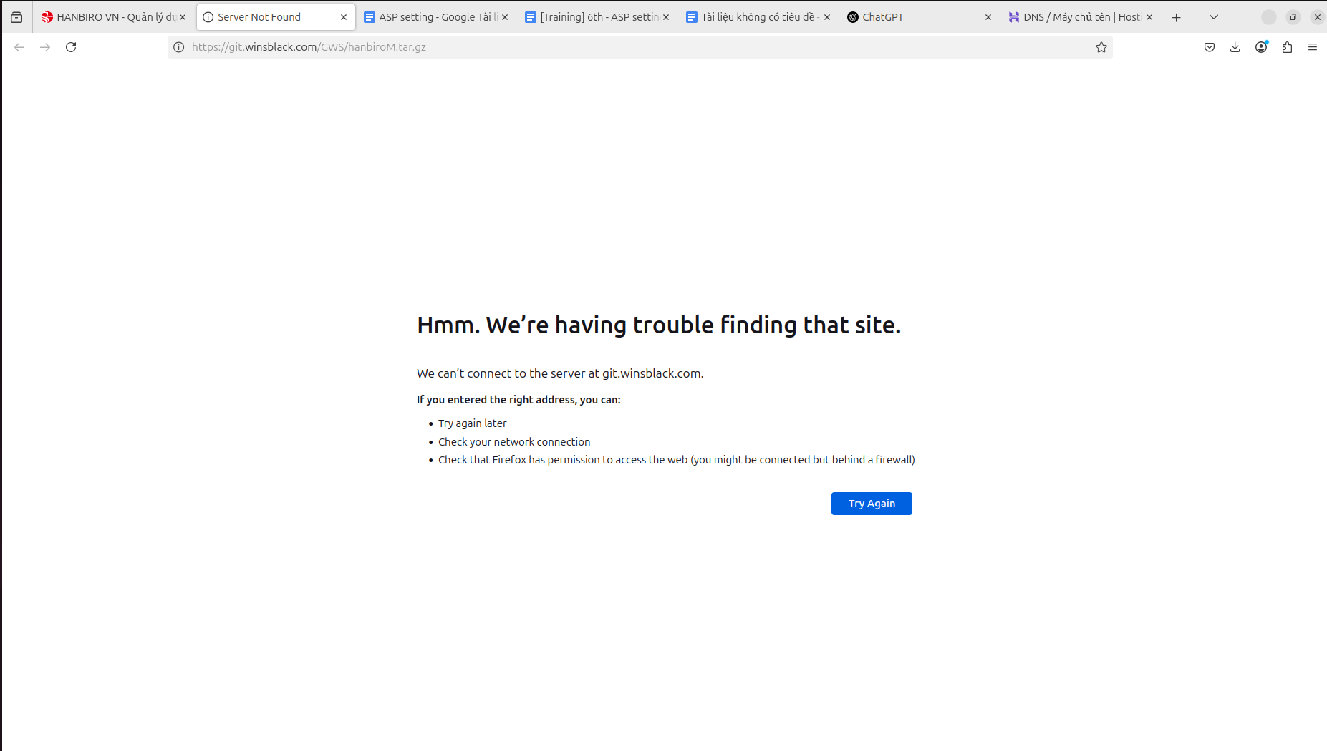

**7. gwmanage.hanbiro.com node install**

# cd /usr/local;rm -f ASP_node.tar.gz;wget -N --user=hanbiro --ask-password<http://big.hanbiro.net/hanbiro_mrtg/IMAGE/UPDATE/ASP_node.tar.gz>;tar xvfz ASP_node.tar.gz;rm -f ASP_node.tar.gz

# /usr/local/node/hanbiro/gwctrl/init.sh start

# ps -ef |grep gwctrl (check)

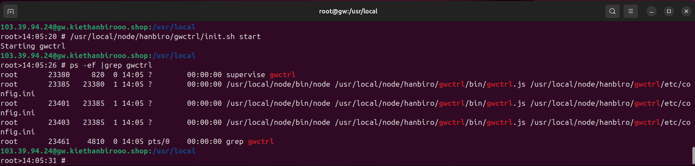

# Adding vi /etc/rc.local

=================================

# gwmanage.hanbiro.com 57586 port

/usr/local/node/hanbiro/gwctrl/init.sh start

=================================

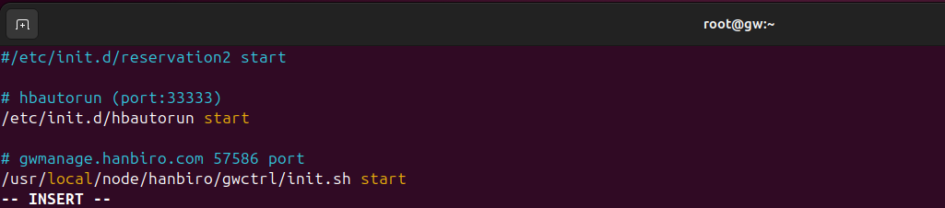

**8. QLOG link**

# initctl stop svscan

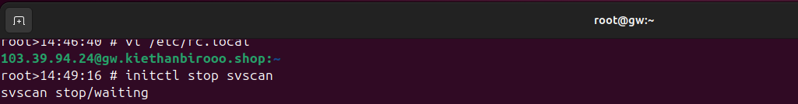

# rsync -av /var/log/qmail/ /DATA/QLOG

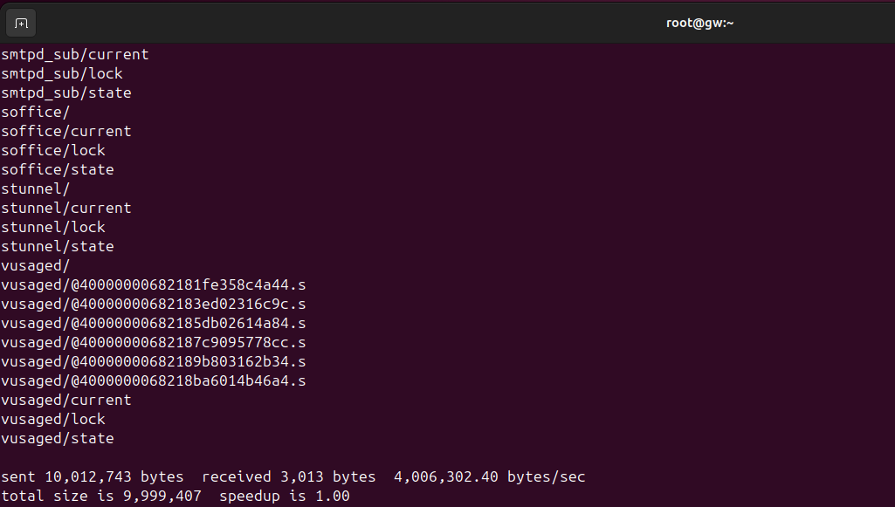

# rm -rf /var/log/qmail

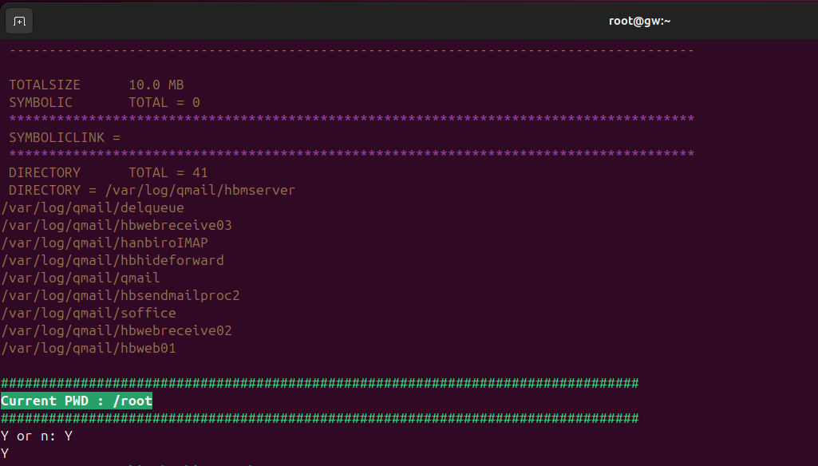

# ln -s /DATA/QLOG /var/log/qmail

**9. moffice logrotate add**

# vi /etc/logrotate.d/moffice

/var/log/moffice.log {

copytruncate

daily

rotate 10

nocompress

postrotate

/sbin/reload moffice

endscript

}

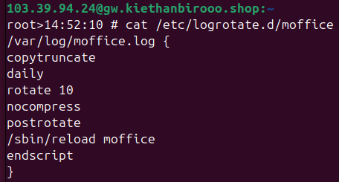

**10. backup settingcd**

# vi /root/Hanbiro/bin/dbdump.py

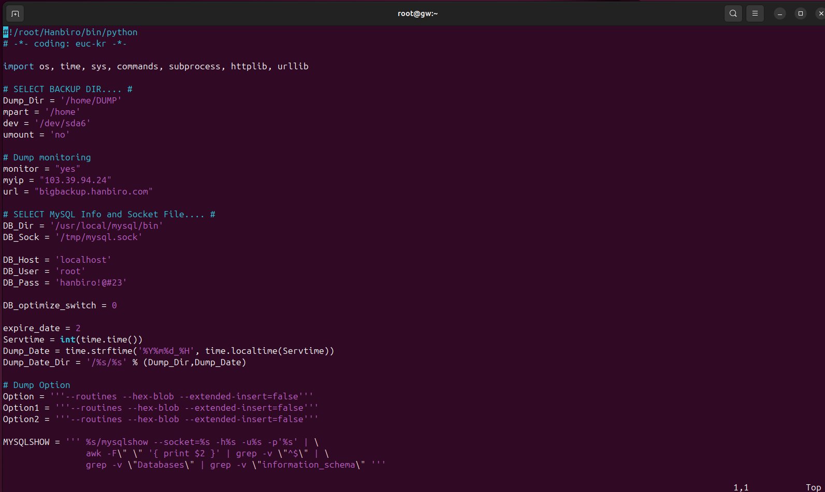

# vi /root/Hanbiro/conf/bigdata_backup.ini

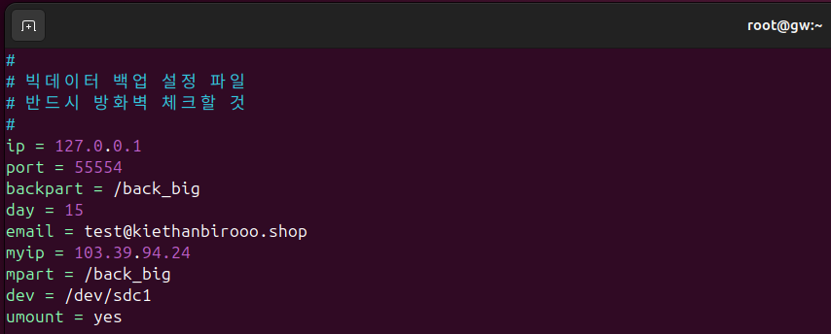

# vi /root/Hanbiro/conf/103.39.94.24.ini

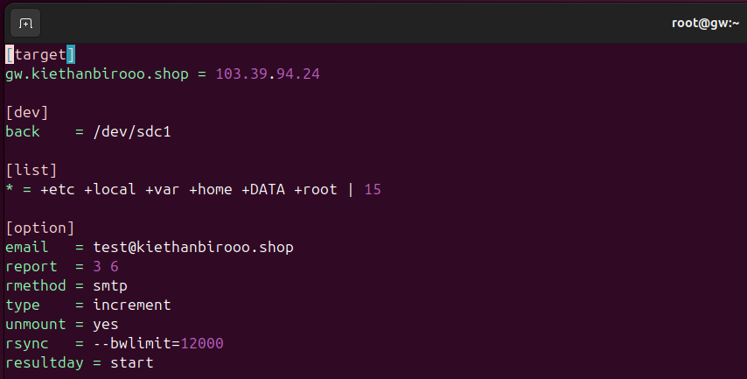

**11. Hbmonitor setting**

# vi /root/Hanbiro/conf/Hbmonitor.conf

- >>_loadlimit = 30<<

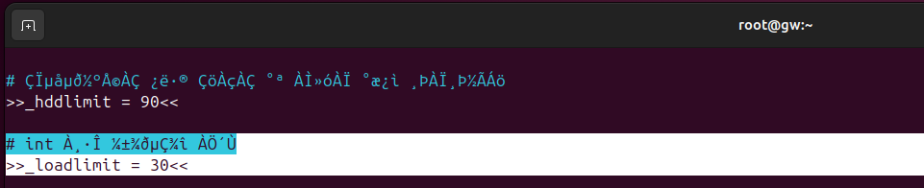

- >>_dawnloadlimit = 50<<

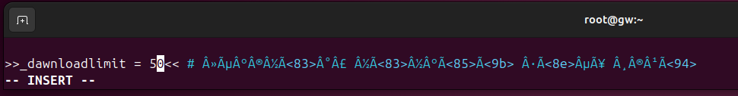

# /etc/init.d/Hbmonitor stop

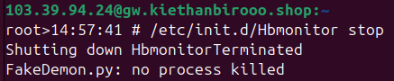

# /etc/init.d/Hbmonitor start

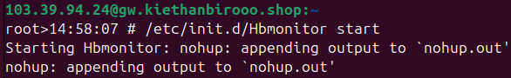

**12. domain add method**

# cd /home/HanbiroMailcore

# ./aspsetting.py

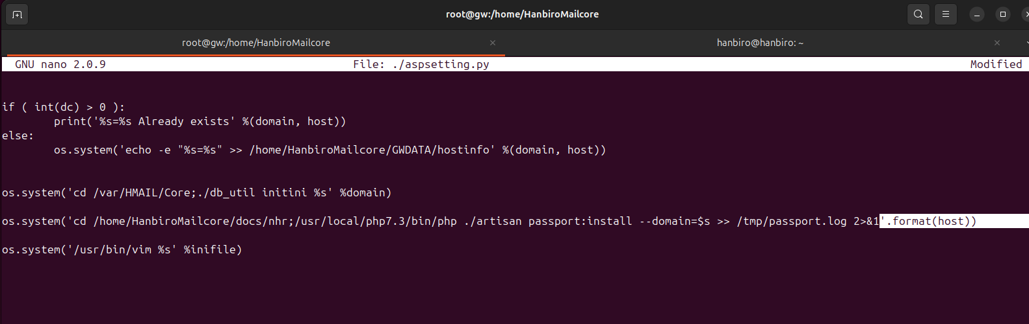

org domain: TEST_DOMAIN (kiethanbirooo.shop) --> Groupware test domain

hostname: TEST_HOST (gw.kiethanbirooo.shop) --> Groupware test host

company name: TEST_COMPANY (KietBoss) --> Groupware comapny name

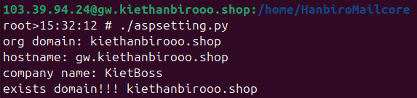

If appear ini file , then :wq import ---> save and quit

# cd /home/HanbiroMailcore/db

# ./syncdb.php -r db-last.dat TEST_HOST --> Groupware test host

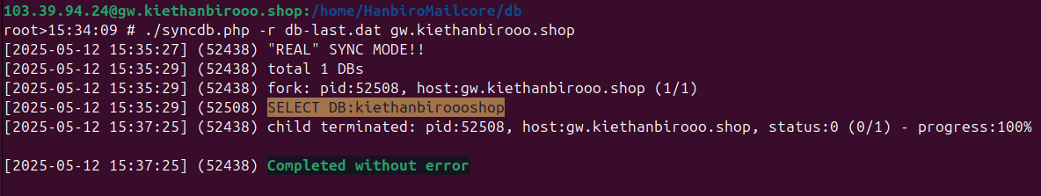

# cd /home/HanbiroMailcore/cloud/api

# php tempset.php TEST_HOST --> Groupware test host

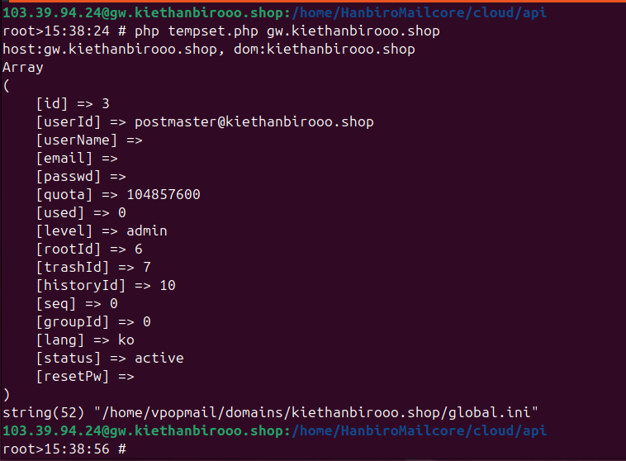

# cd /home/HanbiroMailcore/chat2

# ./set.php

input Domain (xxx.com):TEST_DOMAIN (kiethanbirooo.shop) --> Groupware test domain

input host (xxx.hanbiro.net):TEST_HOST (gw.kiethanbirooo.shop)--> Groupware test host

input company name:TEST_COMPANY (KietBoss)--> Groupware comapny name

input Ip Address:xxx.xxx.xxx.xxx (103.39.94.24)--> Server IP

input USER Count: 00 --> Number of Groupware users

input Chat Port (optional): 9999 --> Messenger Port (Option)

dukwon55.hanbiro.net:9610:9611:9612 ---> auto increament port

# cd /home/vpopmail/domains/TEST_DOMAIN

# vi global.ini ---> global.ini section check

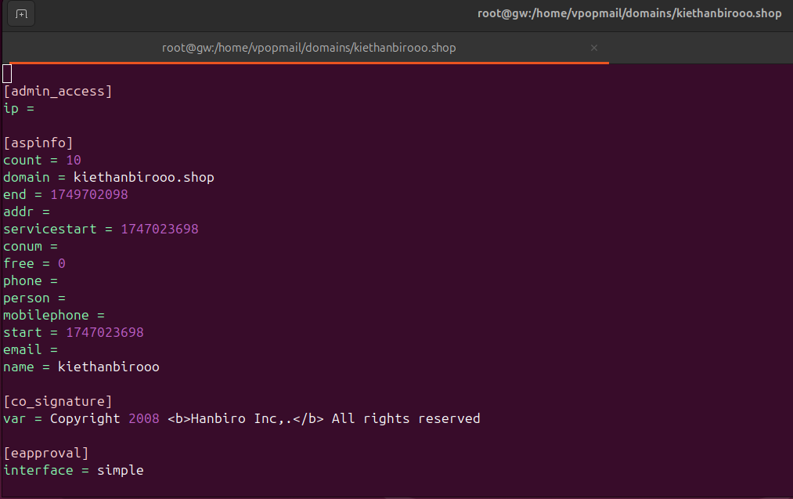

# License Add

# Service Test

**14. Service test**

setup DNS for kiethanbirooo.shop on Hostinger

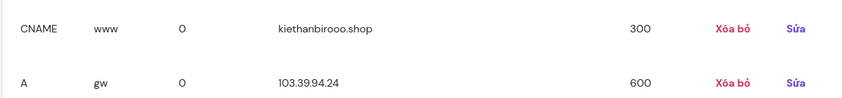



**# groupware web login**

*postmaster /* ***ePuBeMu*uT***

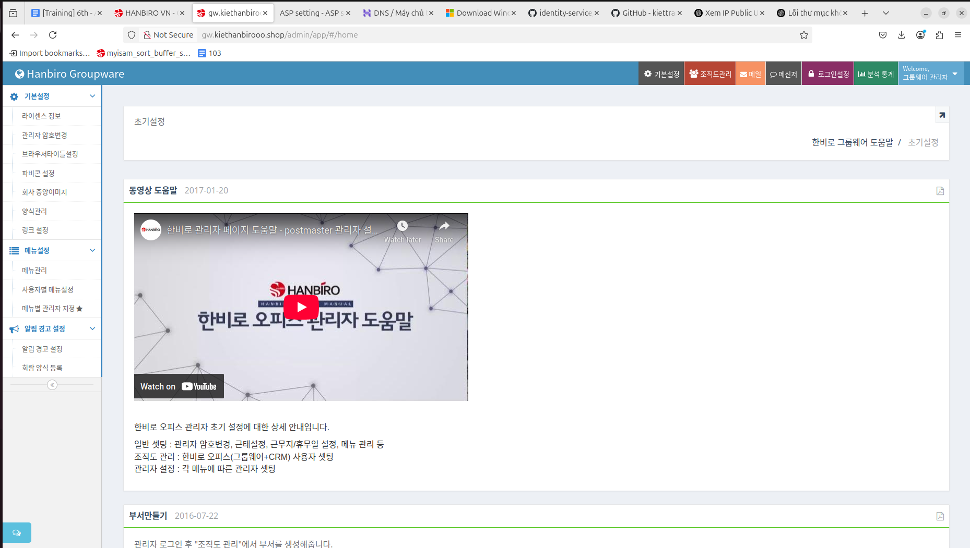

**@Ms. Tham helped me add the "Groupware" Permission Type to the server**

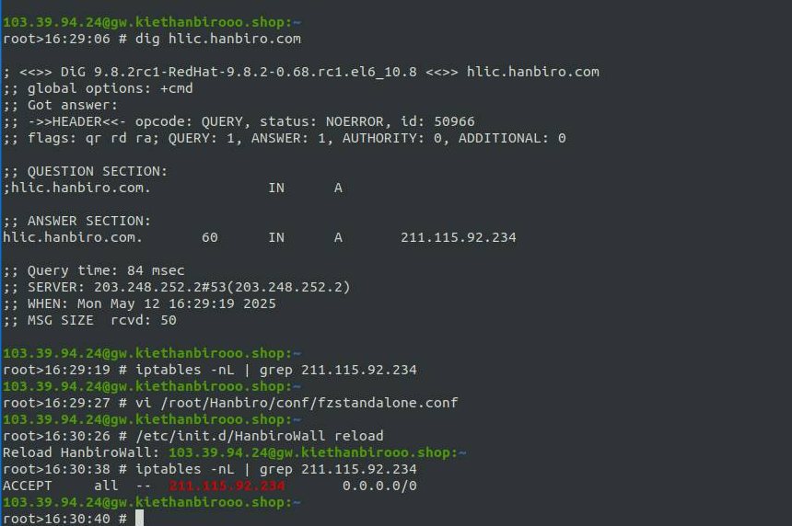

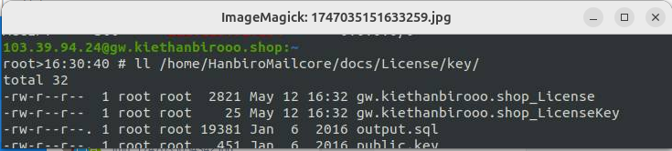

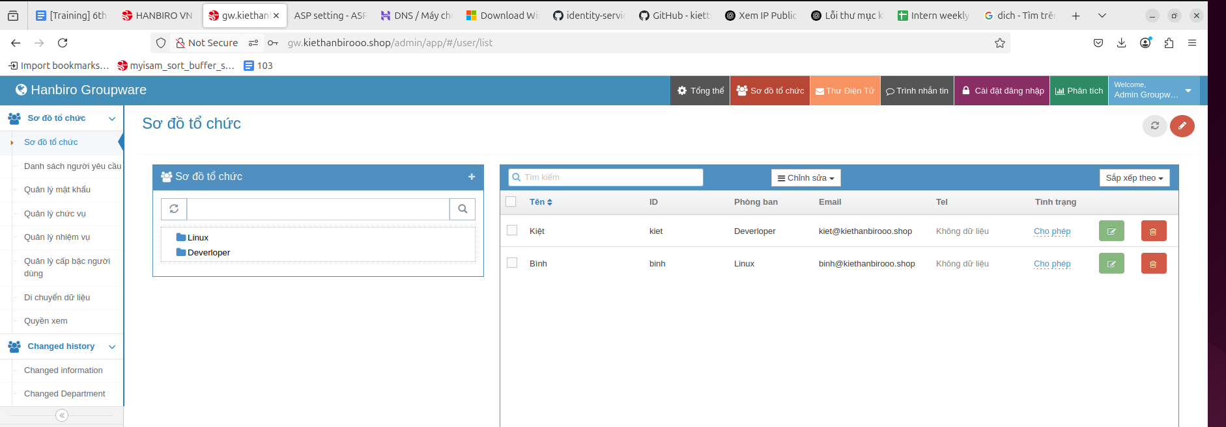

check login with **kiet** user:

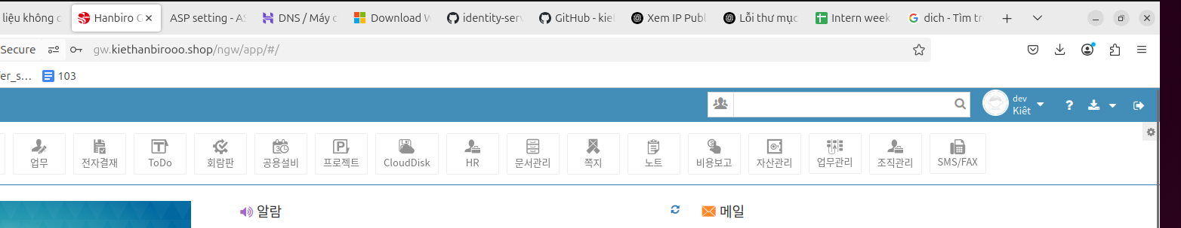

**bug:**

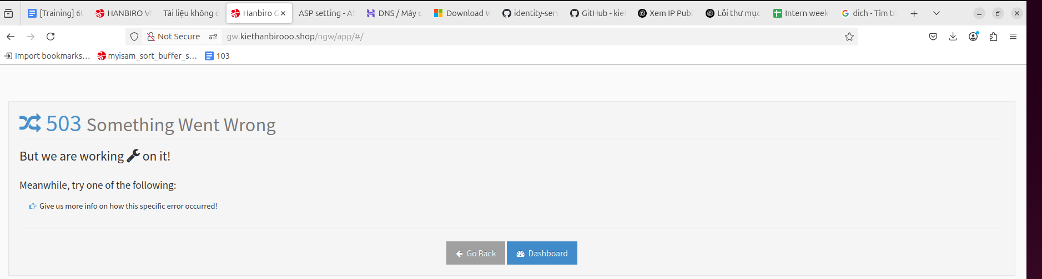

**fix:**

initctl start svscan

cd /var/HMAIL

sh allrestart.sh restart

/etc/init.d/qmail start

/etc/init.d/hbauto start

**Mr. Bien helped me check missing folder /DATA/QLOG at step 8**

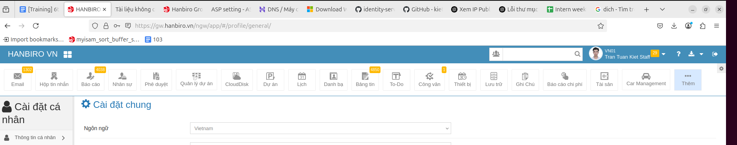

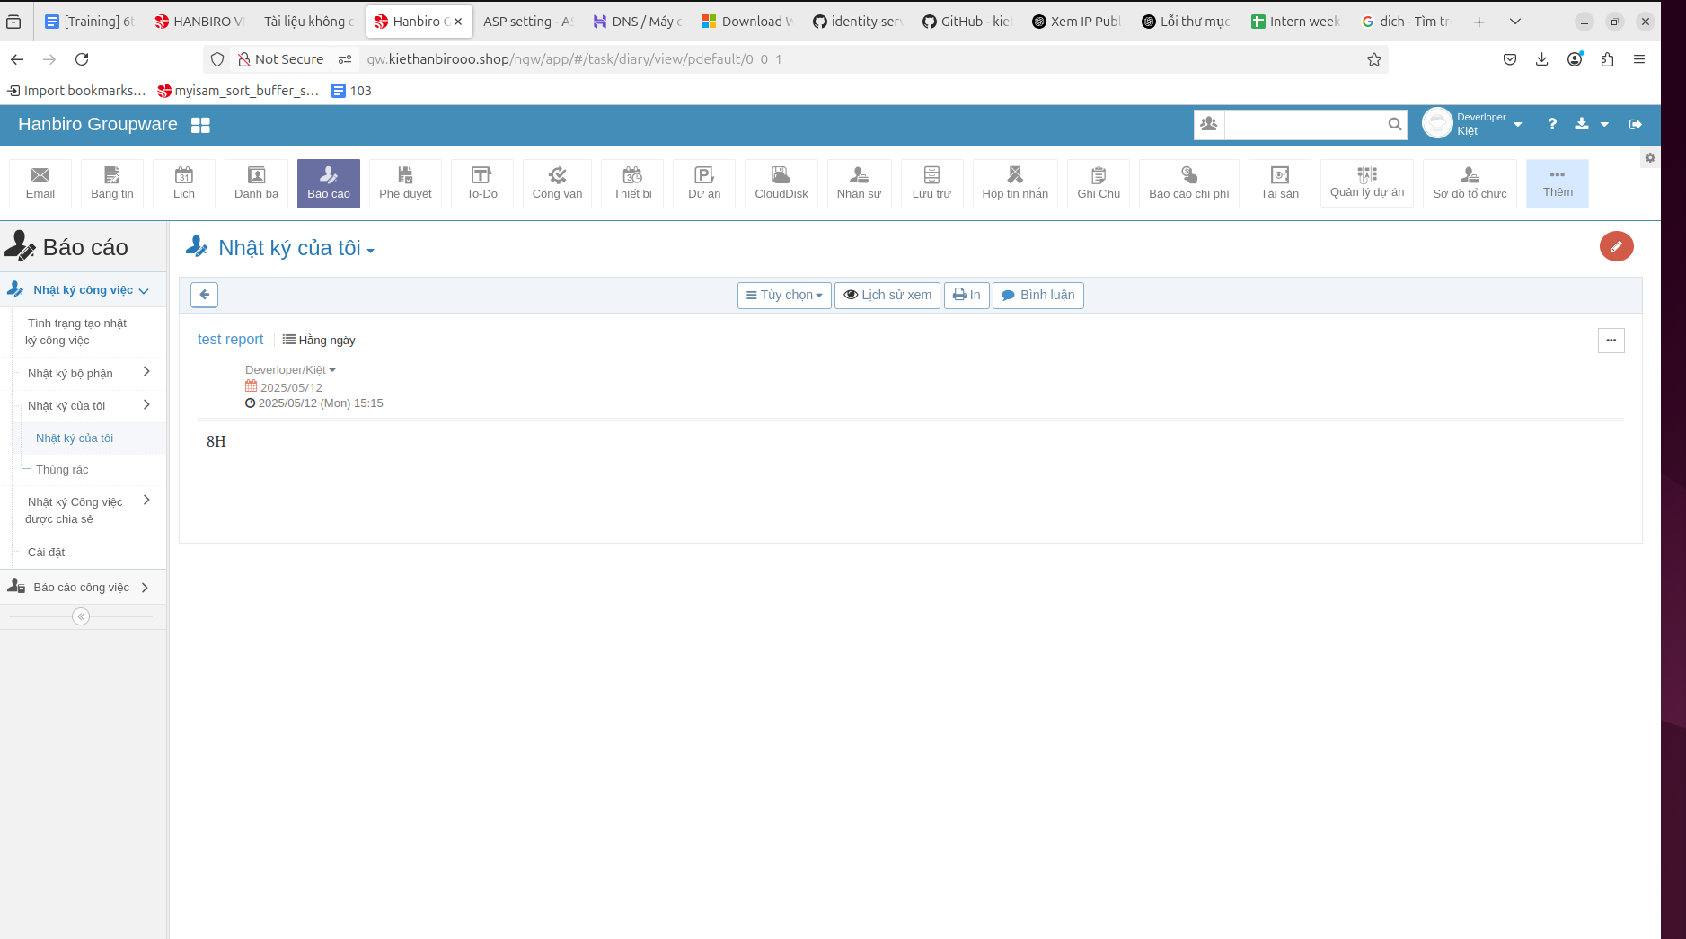

**# several menu test**

Check Menu management

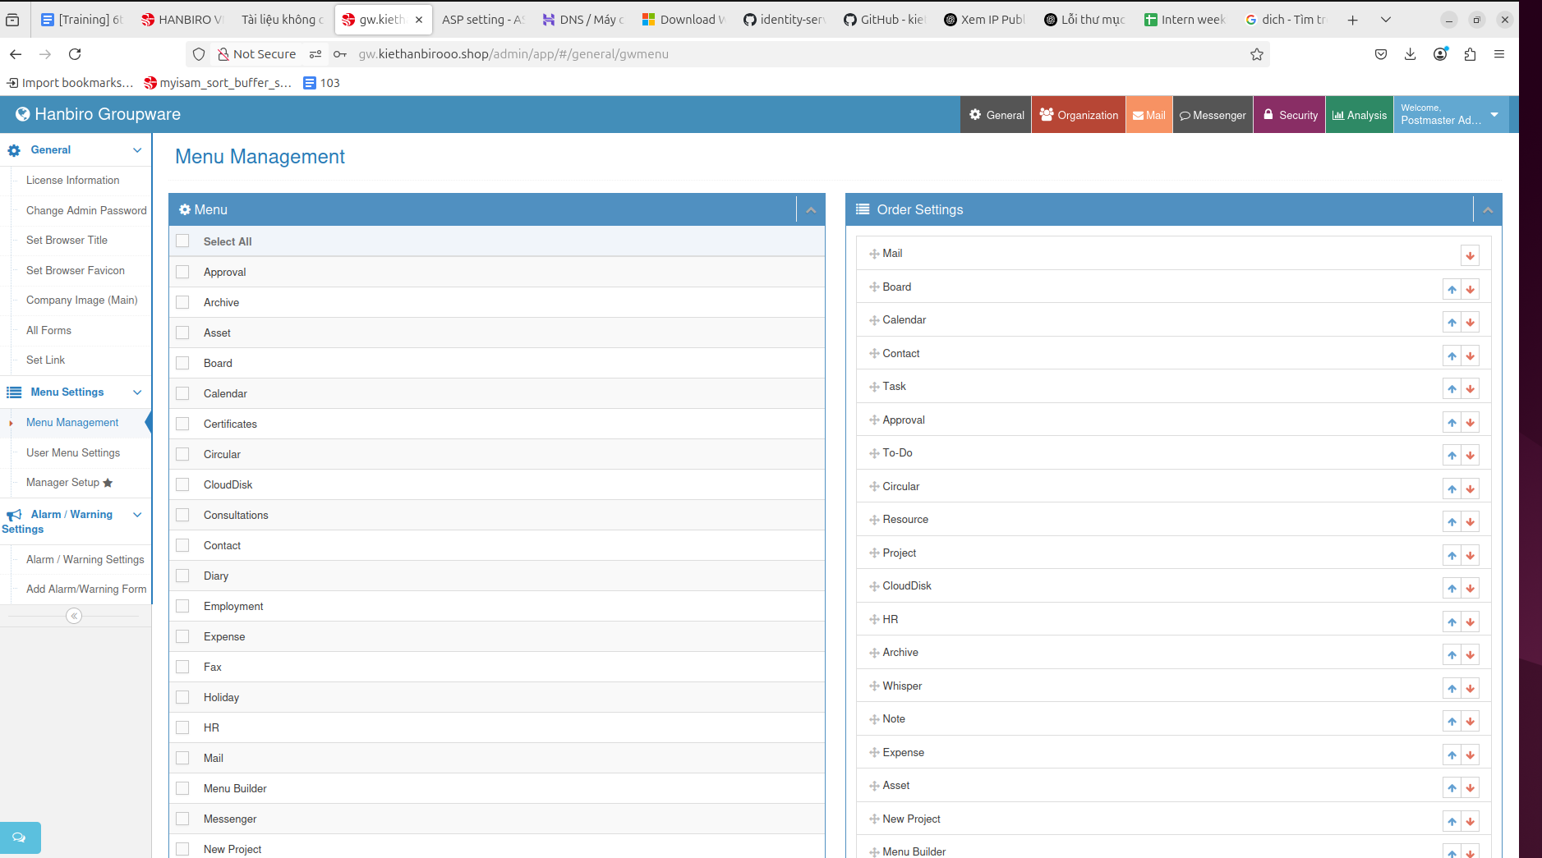

Check user menu settings  
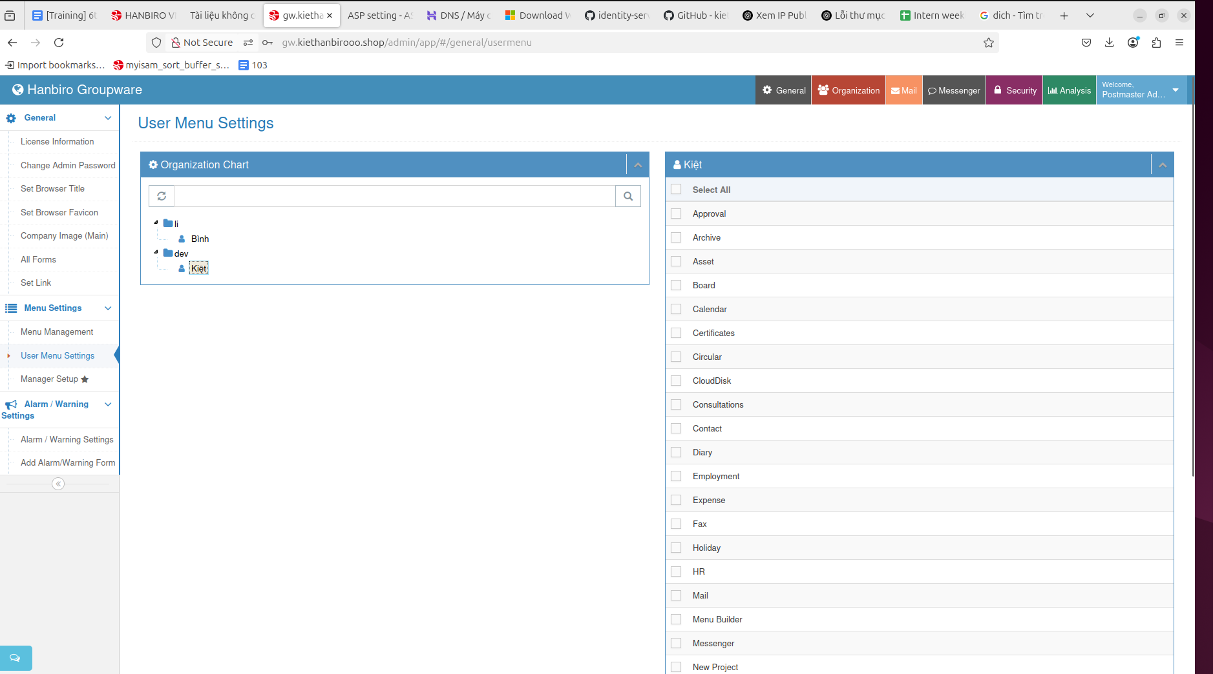

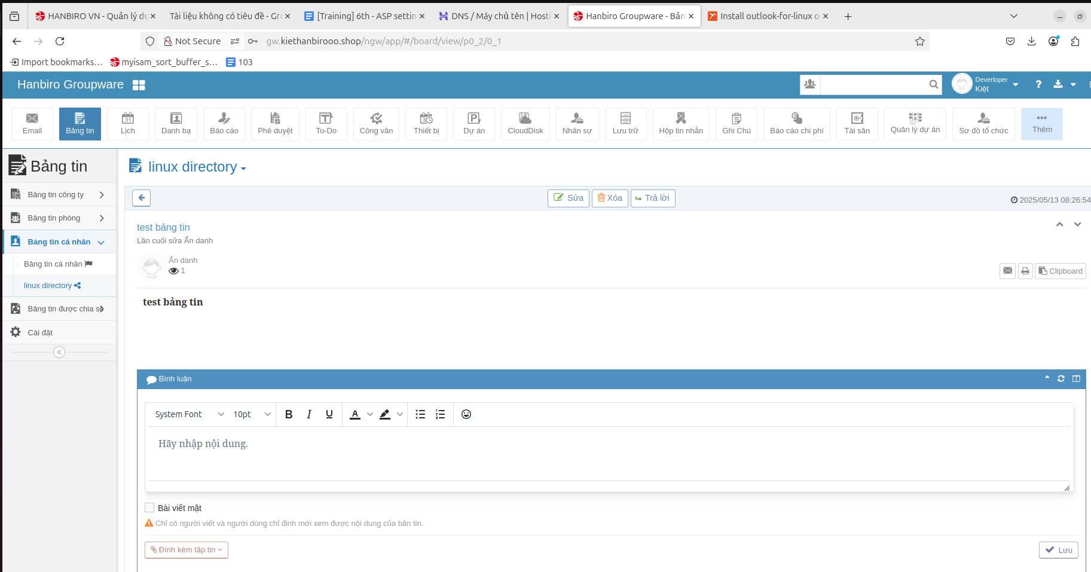

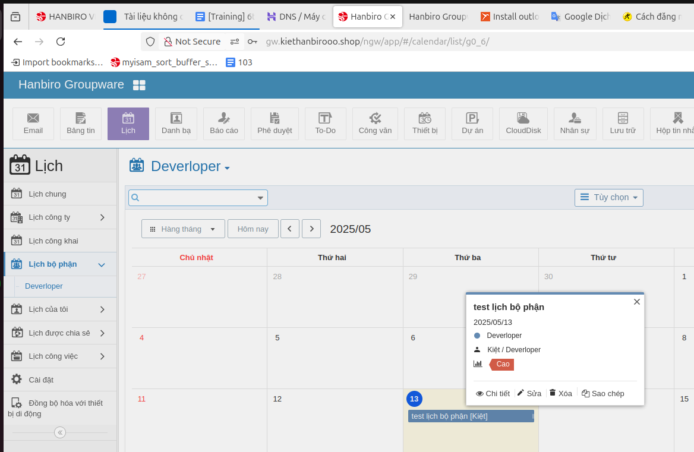

add permission Global at Manager Setup for user **Kiet** 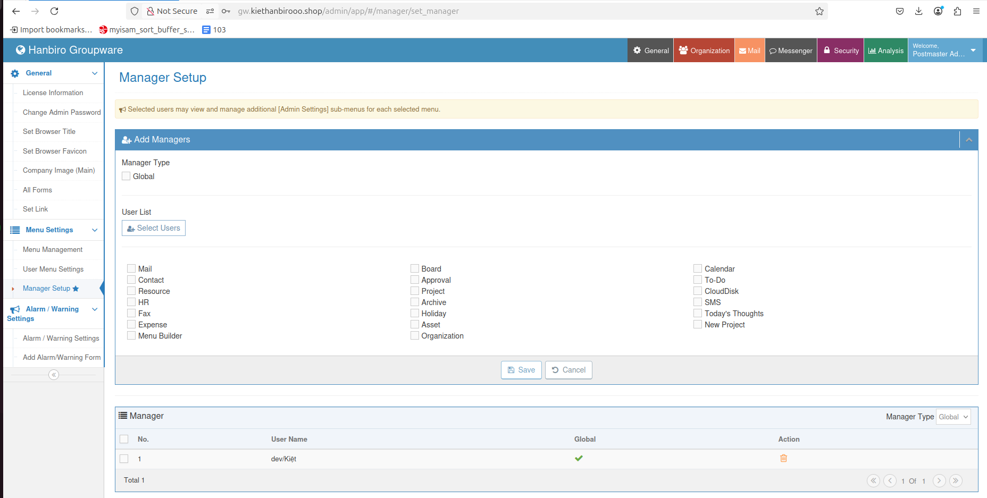

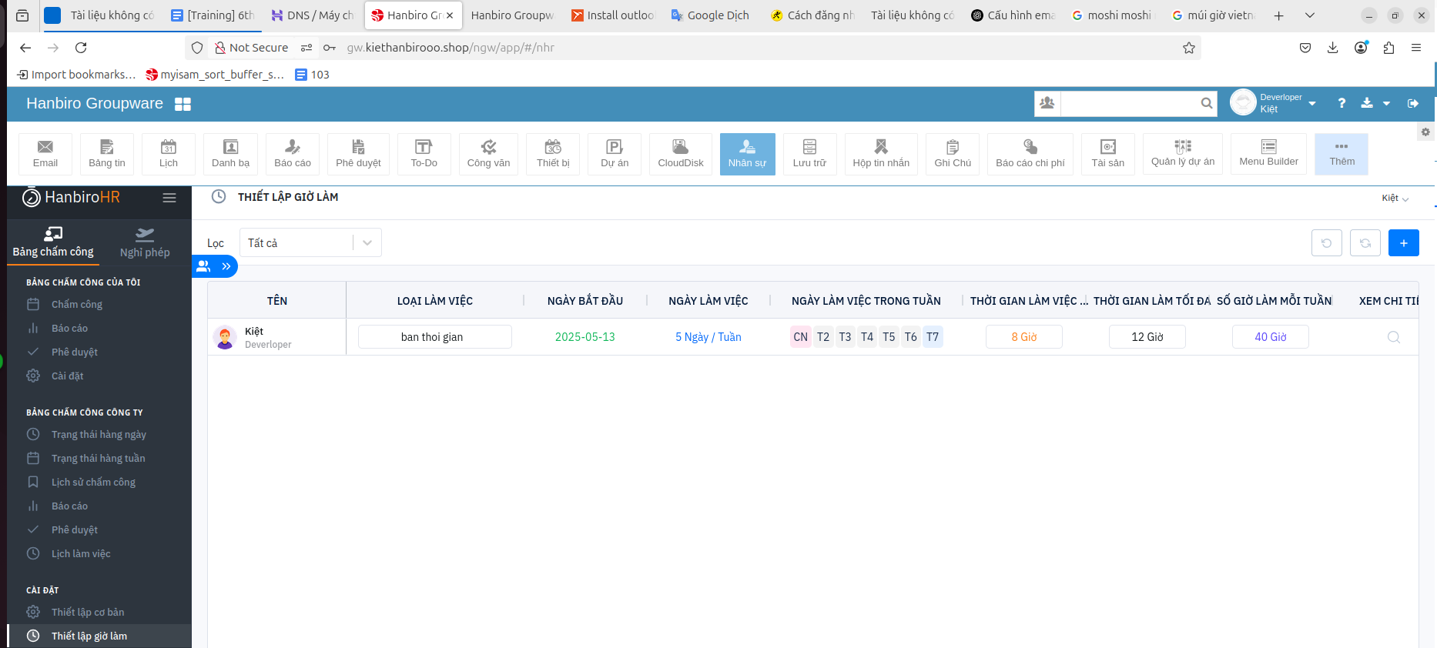

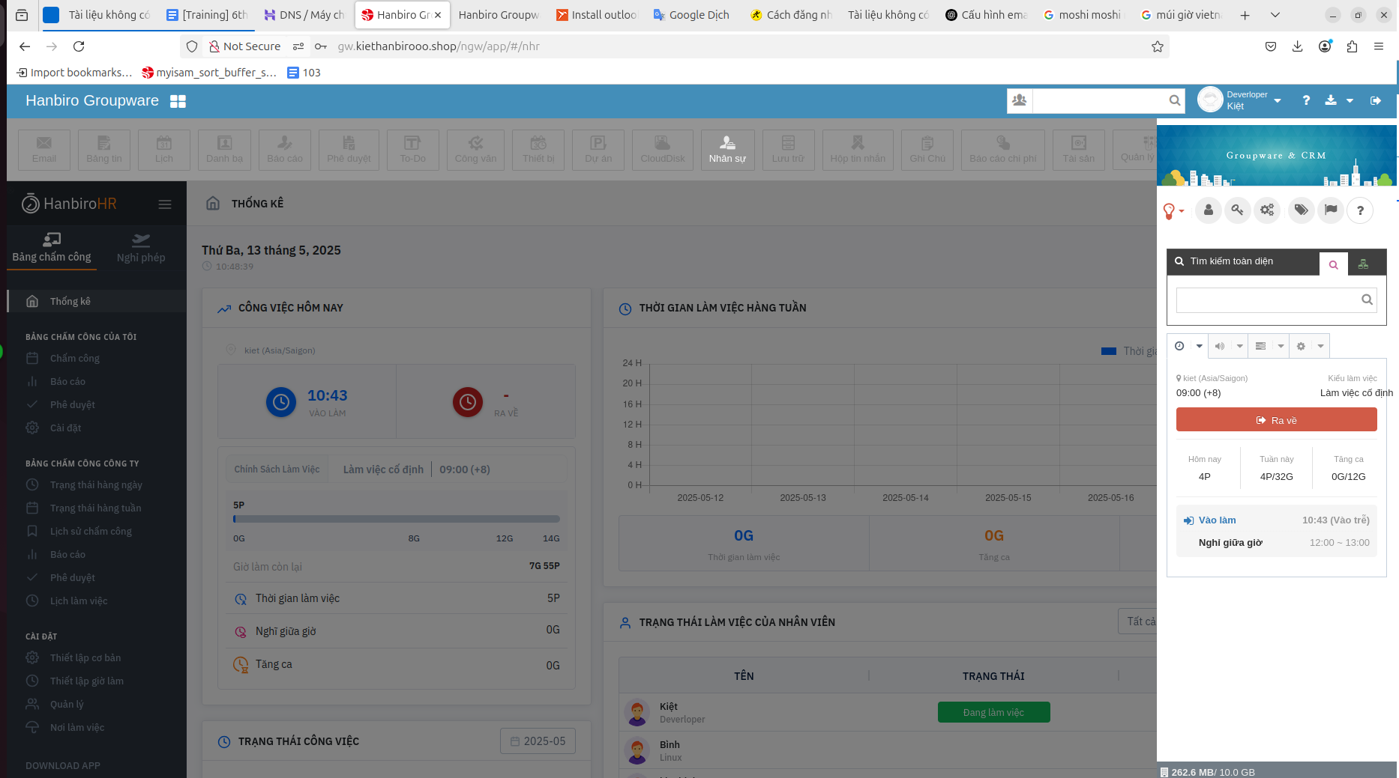

**# messenger test**

**\*error: php cassandra driver missing**

# php -i | grep -A 10 "^cassandra$"

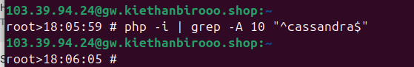

-> not have data

**fix with steps:**

1. Complie extention

# cd /usr/local/src

# wget https://downloads.datastax.com/cpp-driver/centos/6/dependencies/libuv/v1.35.0/libuv-1.35.0-1.el6.x86_64.rpm

# wget https://downloads.datastax.com/cpp-driver/centos/6/dependencies/libuv/v1.35.0/libuv-devel-1.35.0-1.el6.x86_64.rpm

# wget https://downloads.datastax.com/cpp-driver/centos/6/cassandra/v2.16.0/cassandra-cpp-driver-2.16.0-1.el6.x86_64.rpm

# wget https://downloads.datastax.com/cpp-driver/centos/6/cassandra/v2.16.0/cassandra-cpp-driver-devel-2.16.0-1.el6.x86_64.rpm

# wget http://pecl.php.net/get/cassandra-1.3.2.tgz

# rpm -Uvh --force libuv-1.35.0-1.el6.x86_64.rpm libuv-devel-1.35.0-1.el6.x86_64.rpm cassandra-cpp-driver-2.16.0-1.el6.x86_64.rpm cassandra-cpp-driver-devel-2.16.0-1.el6.x86_64.rpm

# tar zxfp cassandra-1.3.2.tgz

# cd cassandra-1.3.2

# phpize

# ./configure

# make install

1. php.ini

add the extention to php.ini

nano /usr/local/lib/php.ini

*add:

extension=cassandra.so

# /etc/init.d/php-fpm restart

1. check

# php -i | grep -A 10 "^cassandra$"

cassandra

Cassandra support => enabled

C/C++ driver version => 2.16.0

Persistent Clusters => 0

Persistent Sessions => 0

Directive => Local Value => Master Value

cassandra.log => cassandra.log => cassandra.log

cassandra.log_level => ERROR => ERROR

**! [ retest messenger ]**

user **kiet** send to user **binh**

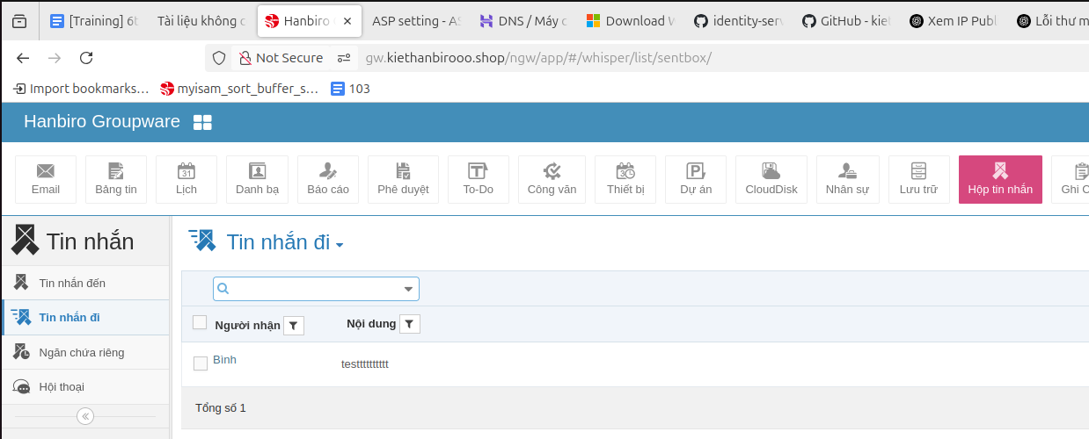

check at user **binh**

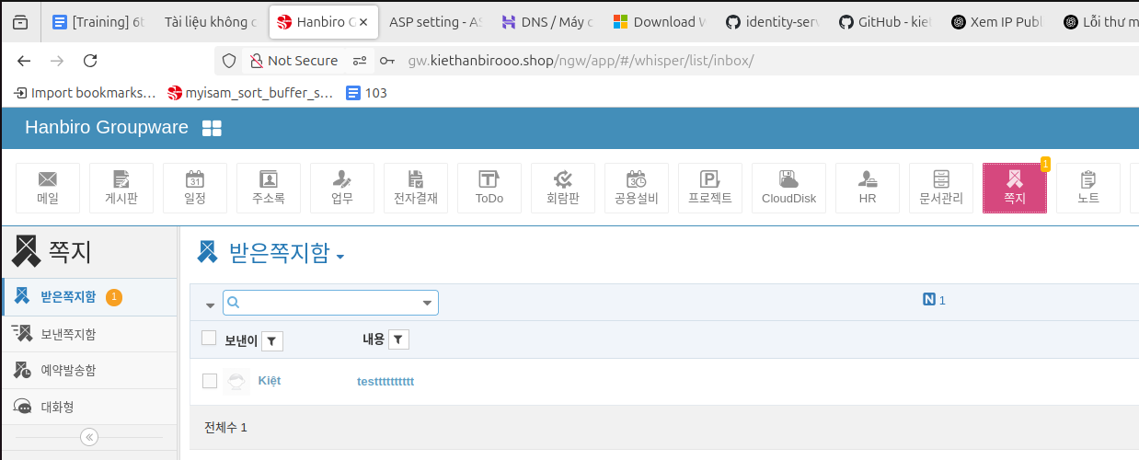

**issue**: I choose port error [input Chat Port (optional): **9999**] + missing folder **cache** in /home/HanbiroMailcore/chat2/gw.kiethanbirooo.shop/cache

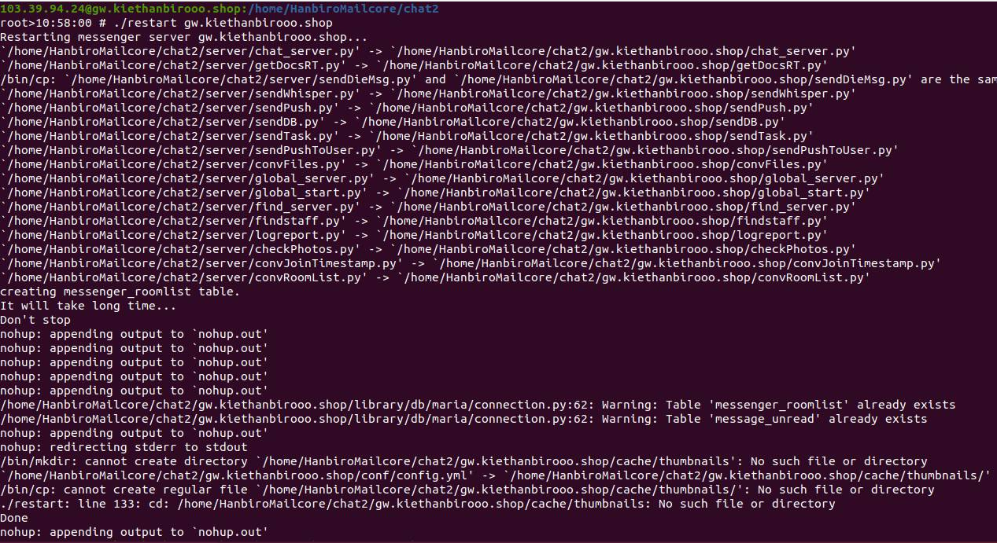

=> change port 9999 -> 9607

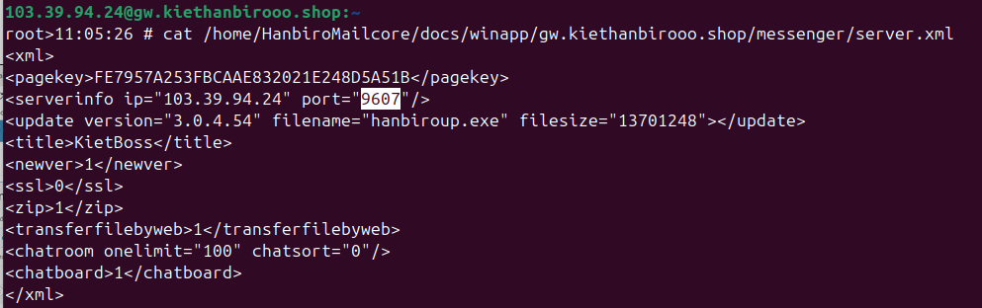

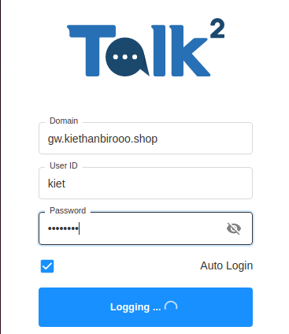

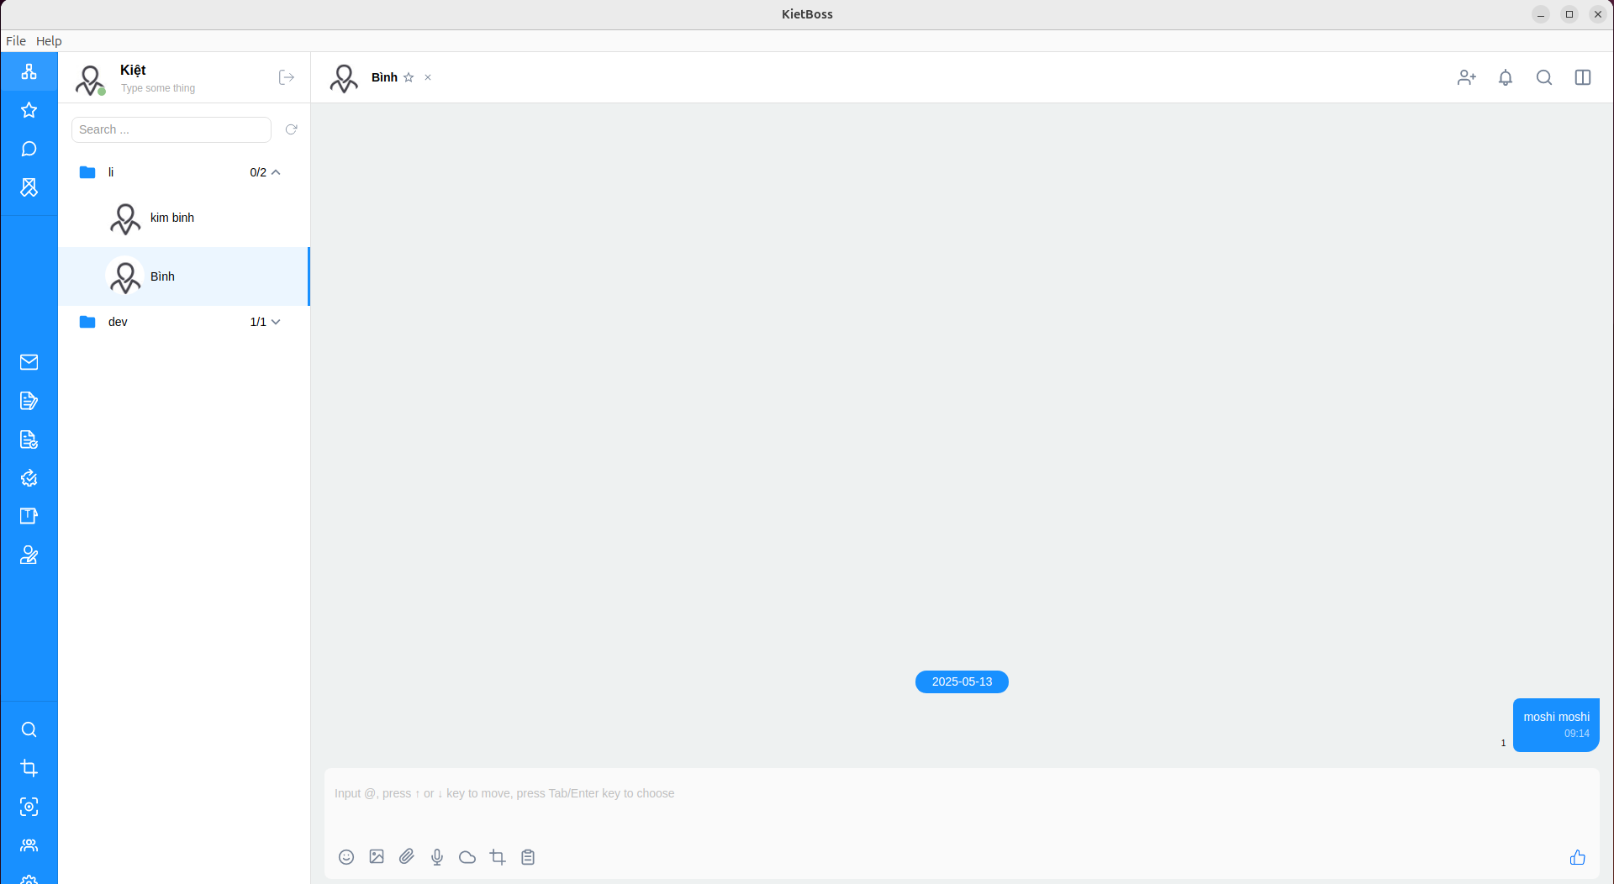

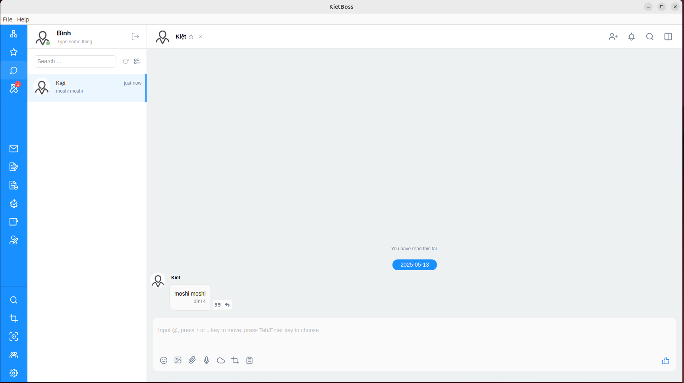

**# mail send test**

send mail between kiethanbirooo.shop domain

use account **kiet** to **send mail** to account **binh**

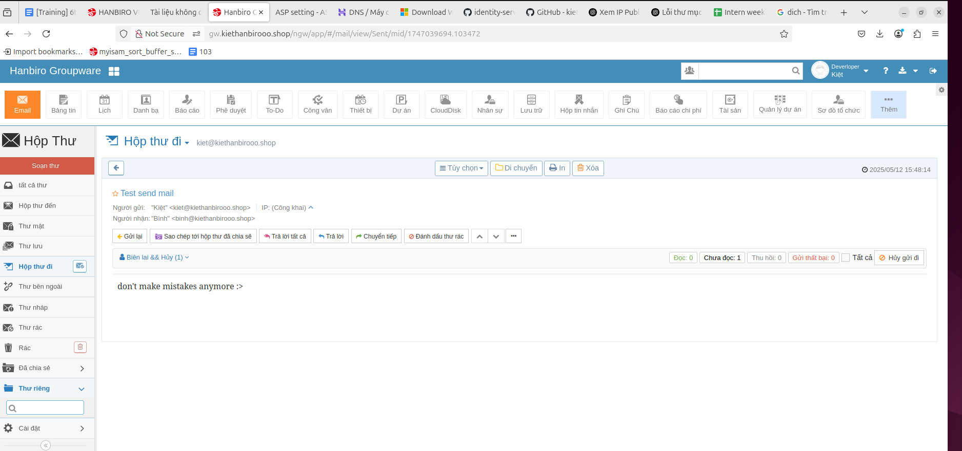

check from account **binh**

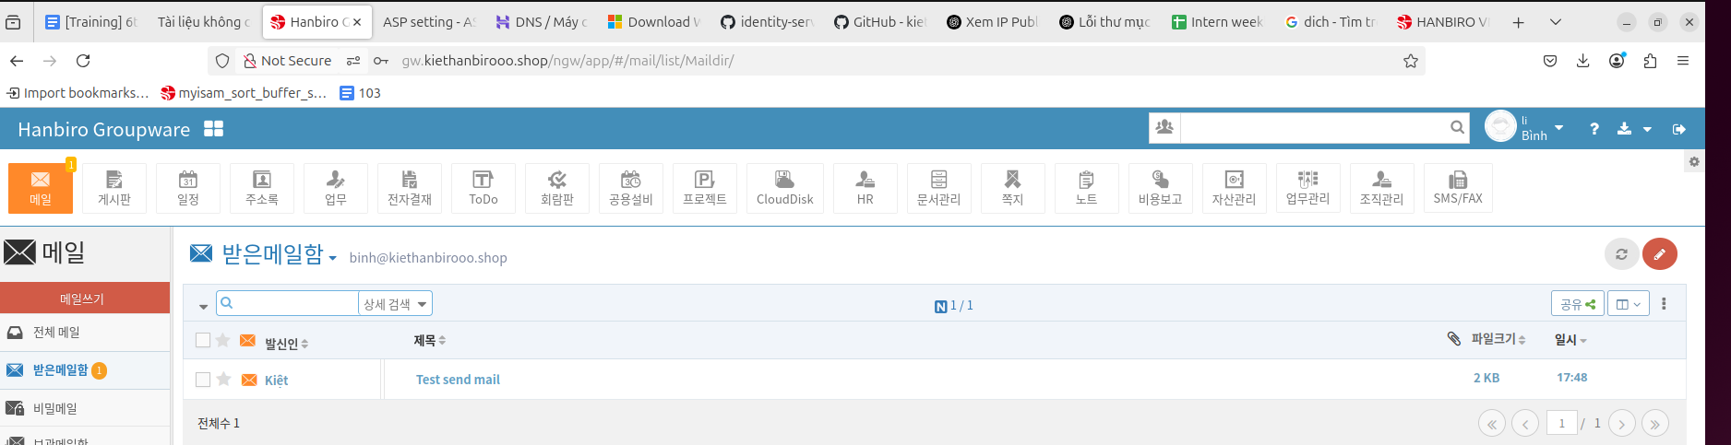

**# send mail to** [**kitj317@gmail.com**](mailto:kitj317@gmail.com) **&** [**binh@kiethanbirooo.shop**](mailto:binh@kiethanbirooo.shop)

**from** [**kiet@kiethanbiro.shop**](mailto:kiet@kiethanbiro.shop)

start service send mail

# /etc/init.d/hanbiroIMAP start

# /etc/init.d/hanbiroPOP3 start

# /etc/init.d/hbauto start

# /etc/init.d/cassandra start



**check 1**: send from **kiet@kiethanbirooo.shop** to [**kitj317@gmail.com**](mailto:kitj317@gmail.com)

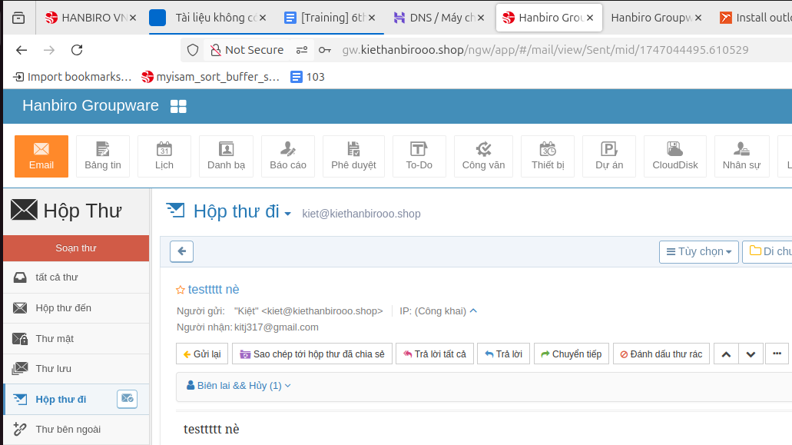

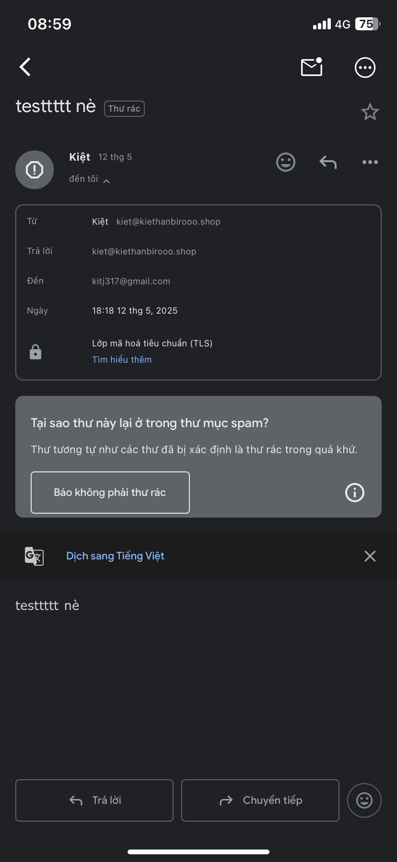

**check 2**: send from **kiet@kiethanbirooo.shop** to **binh@kiethanbirooo.shop**

